**IBM DATA SCIENCE CAPSTONE PROJECT REPORT**

**RECOMMENDATION OF AFFORDABLE HOUSING IN LONDON**

**Nithya Lakshmi**

**Table of Contents :**

* Introduction
* Data acquisition and pre-processing
* Formulation of methodology
* Tools used
* Statistical Inferences
* Results and discussion
* Conclusion
* Acknowledgement

**INTRODUCTION**

**A brief background**

According to the house pricing statistics of UK , London is one of the most expensive places to live in. The real estate business is on a short fall due to the decreased number of house purchases in the recent decade , especially in the past 5 years. According to a 2018 census report , more and more residents in UK and especially in London are opting to rent out condominiums and apartments(60%) .These rank highest in rental and purchases , causing a downfall in purchase of homes for families. The increased pricing might not subdue owing to the prospect of higher taxes and a warning from the Bank of England that U.K. home values could fall as much as 30 percent in the event of a disorderly exit from the European Union causing real estate agencies to back out. More specifically, four overlooked cracks suggest that the London market may be in worse shape than many realize: hidden price falls, record-low sales, homebuilder exodus and tax hikes addressing overseas buyers of homes in England and Wales.

**Target audience:**

There are many families longing to buy their own homes , but with the increasing dilemma of unaffordable house pricing , these real estate clientele have to opt out of their housing preference with a different place to call their "home". Thus this project aims to help resolve this issue for anyone trying to buy a home in London and to real estaters who can help suggest good residential plots.

**Business problem :**

The question at hand is Are there medium priced houses available for purchase in London? if so , is the construction sound or compromised in lieu with the minimal cost. Are there houses available in good localities with access to amenities such as hospitals , gyms , schools etc. All in all the project aims at rendering support to those interested in buying their own homes, to help the make wise and effective decisions under ongoing financial and economic constraints.

## Data Section

### Data Description

In this section a brief overview of the data used for the case study is given. In order to get a comprehensive understanding of the question or the business problem posed, it is necessary to obtain a clear understanding of the situations that influence the problem. The data chosen to work on was obtained from <http://landregistry.data.gov.uk/> -website containing information on UK real estate , house pricing and registries. Cross referencing was also done with various websites to obtain any readily available information on housing prices and preferences , a list of which has been provided below.

1. <https://www.testbig.com/ielts-writing-task-i-essays/chart-illustrates-housing-preferences-among-people-who-lived-british>
2. <https://www.homesandproperty.co.uk/property-news/buying/the-best-areas-to-start-your-search-for-a-family-house-with-good-links-to-the-city-a116886.html>
3. <https://www.zoopla.co.uk/discover/first-time-buyers/london/#4jJFWixLL2Hl0cuD.97>

The land registry data contains information regarding all housing registries made in the UK. It comprises of columns containing unique id, price of house purchased, date of purchase, address(street, city, district)info , age of housing and pin codes. However , the tabular data imported will have to be pre-processed as per the scope of this case study. Since, the business problem is associated only with London , London specific data must be filtered out from the data set and unnecessary data must be dropped.

In order understand the pricing affordability of customers , data regarding buying trends in first time home buyers is observed to get an approximation of mean price preference.

Leveraging the use of Foursquare API, folium and geopy in order to obtain location data and venues in the vicinity of our target areas is done to increase the probability of suggesting a good locality with suitable amenities. The data will be clustered using K-means clustering , a machine learning algorithm used to group similar patterns together. This would help in recommending locations based on customers with similar or specific preferences.

### Data accumulation to solve the business problem:

1. House purchase real estate record data of UK from which a list of London streets and their corresponding average purchase prices can be obtained.
2. Average house costing data in Greater London to get an average price estimate that we are looking for
3. geopy to obtain geographic coordinates for visualization
4. Foursquare API to obtain venues near each of the localities
5. Folium map to mark and observe the neighbourhoods

The average purchase price for a first time buyer in Greater and Central London is around £509,047 while in South East London it costs around £339,510.Let us take a look at the data set of some of the cheapest housings in Greater London.

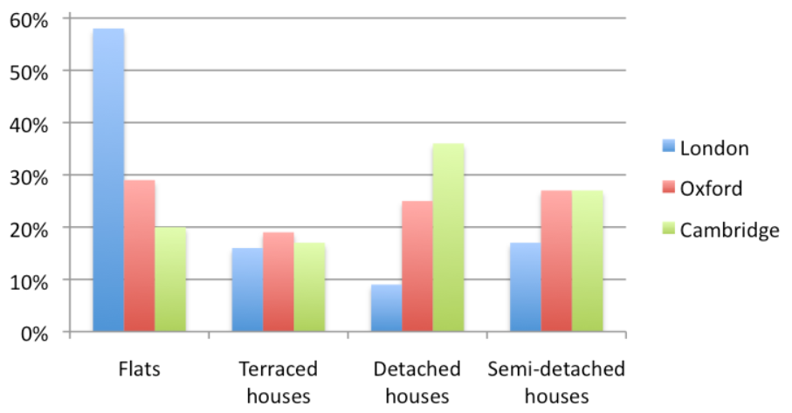

The above graph illustrates the housing preferences in London in that past 10 years. As is evident from the graph almost 60% of the people preferred flats as a residence in comparison to independent housing due to various economical factors. Thus , it only seemed relevant to be able to provide housing suggestions to those interested in purchasing good quality independent homes , which is the final aim of this project.

**The data acquired was used in the following manner:**

**Step 1**: Determining average cost of housing from information derived on affordable housing in great London.

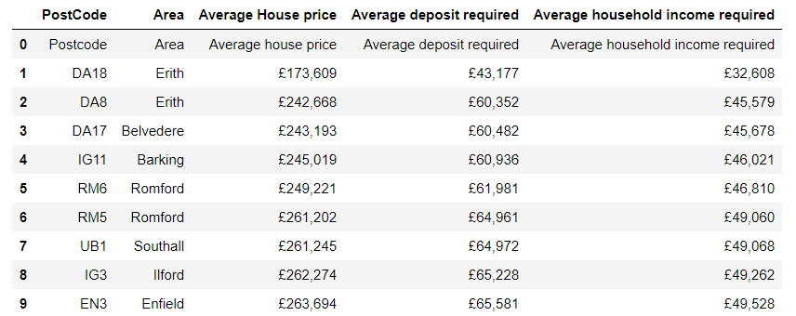

The above information was webscraped and converted into a dataframe in order to obtain average house pricing preferred.

From the above table it can be observed that the average price of some of the well known localities in greater London , one of the most expensive of places, is £2,202,125.The amount was used as a base estimate to determine a suitable pricing range chosen to be between £2,000,000 and £3,000,000.

## Data Preprocessing:

## The data used for the project was obtained from the UK real estate website.However , in order to analyse , redundant and insignificant data was removed. It involved :

## Importing data and renaming /formatting columns

## Dropping data / columns that would not be required for further analysis

## Rearranging data according to the date or year in order to work with recent information.

## Filtering out LONDON specific information by grouping data based on streets that contained the word LONDON.

* Determining average House pricing in each street and filtering out those in the range of £2,000,000 and £3,000,000.

## Obtaining the geographical coordinates of these localities using geopy.

## Obtaining a general visualization of the streets on the map of London using Folium.

## 

## House purchases in UK

## 

## Streets in LONDON with specified average house pricing within range and their respective coordinates.

## METHODOLOGY:

## After the required data to work with has been obtained with the use of tools like FOURSQUARE API the most common venues in the vicinity were determined.

## The methodology section aimed at :

## Obtaining the most common venues in the vicinity of each street in order to find those with relevant amenities using FOURSQUARE.

## Explore the neighbourhoods to see if hospitals , schools and gyms and other facilities of importance are within a 2km radius in order to combine pricing with amenities.

## Statistical comparison of amenities using box plots

## Clustering through machine learning algorithm K-means clustering to segment the streets into similar groups that can be prioritized for recommendation.

## Plotting the clusters to obtain a visualize and draw inferences.